Clear or Precise Pronunciation Diction

🔊 What is Clear/Precise Pronunciation
# Source: Chatgpt (GPT-4-turbo) at [7/30/2025]
Clear/Precise pronunciation refers to the accurate articulation of sounds and syllables in spoken language. It is a form of spoken diction that emphasizes clarity, correctness, and intelligibility in how words are pronounced.

✅ Key Features:
# Source: Chatgpt (GPT-4-turbo) at [7/30/2025]
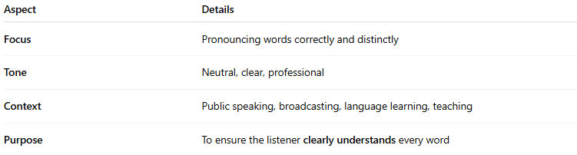
Aspect | Details
Focus | Pronouncing words correctly and distinctly
Tone | Neutral, clear, professional
Context | Public speaking, broadcasting, language learning, teaching
Purpose | To ensure the listener clearly understands every word

🧠 Examples of Clear/Precise Pronunciation:
# Source: Chatgpt (GPT-4-turbo) at [7/30/2025]
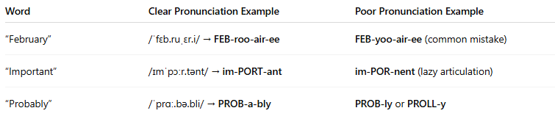
Word | Clear Pronunciation Example | Poor Pronunciation Example
“February” | /ˈfɛb.ruˌɛr.i/ → FEB-roo-air-ee | FEB-yoo-air-ee (common mistake)
“Important” | /ɪmˈpɔːr.tənt/ → im-PORT-ant | im-POR-nent (lazy articulation)
“Probably” | /ˈprɑː.bə.bli/ → PROB-a-bly | PROB-ly or PROLL-y

🎤 How It's Used:
# Source: Chatgpt (GPT-4-turbo) at [7/30/2025]
- In teaching: Helps language learners form words accurately.
- In acting or speech: Used to project voice and enhance articulation.
- In professional settings: Prevents misunderstandings in presentations or calls.
- In AI/voice tech training: Models of correct pronunciation.

🆚 Pronunciation-Based Diction vs Vocabulary-Based Diction:
# Source: Chatgpt (GPT-4-turbo) at [7/30/2025]
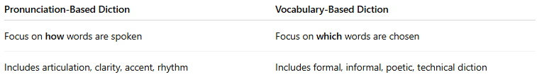
Pronunciation-Based Diction | Vocabulary-Based Diction
Focus on how words are spoken | Focus on which words are chosen
Includes articulation, clarity, accent, rhythm | Includes formal, informal, poetic, technical diction

🧭 Used In:
# Source: Chatgpt (GPT-4-turbo) at [7/30/2025]
- Language learning and teaching
- Public speaking
- Voice acting, news broadcasting
- Speech therapy
- Call centers and customer service

